

**Operations and Maintenance Document**

Department of Veterans Affairs,

Pre-Procedure Checklist Tool

VA118-11-RQ-0508

**Intellica Corporation**

**209 W. Poplar**

**San Antonio, Texas 78212**

**01/25/2012**

# Table of Contents

Table of Contents 2

Change Log 3

Introduction 3

Start, Stop and Restart the Website 4

Application Pool Start, Stop and Recycle 4

Start, Stop and Restart Oracle Services 5

Backing up Server Log Files 6

Backing up Web Server IIS Log Files 7

# Change Log

|  |  |  |  |
| --- | --- | --- | --- |
| Date | Version # | Author | Revision Description |
| 01/25/2012 | 1 | Craig Rebo | Created |
|  |  |  |  |
|  |  |  |  |
|  |  |  |  |
|  |  |  |  |
|  |  |  |  |
|  |  |  |  |

# Introduction

This document describes the operations and maintenance for the Pre-Procedure checklist tool.

# Start, Stop and Restart the Website

The following are procedures for starting, stopping and restarting the Pre-Procedure Checklist Website.

1. Login to the Web Server and open Internet Information Services Manager (IIS)

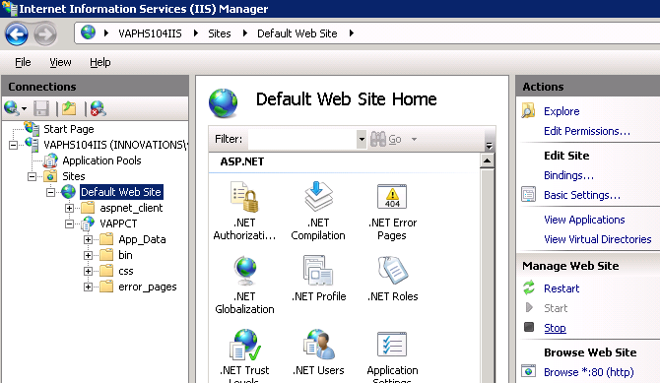

1. Select the ‘Default Web Site’ and choose ‘Restart’, ‘Start’ or ‘Stop’

# Application Pool Start, Stop and Recycle

The following are procedures for starting, stopping and restarting application pools used by the Website.

1. Login to the Web Server and open Internet Information Services Manager (IIS)

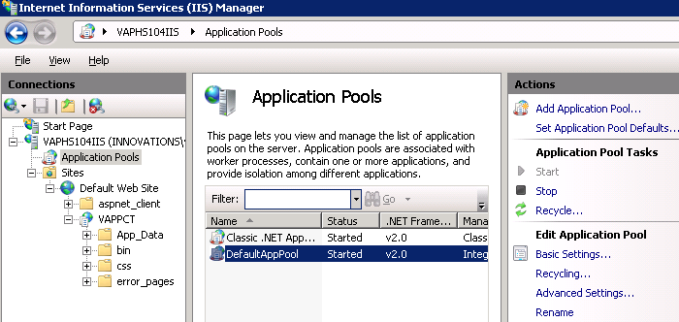

1. Select ‘Application Pools’ from the left pane.
2. Select the application pool and choose ‘Start’, ‘Stop’ or Recycle.

# Start, Stop and Restart Oracle Services

The following are procedures for starting, stopping and restarting Oracle Services.

1. Login to the Database server and open the Windows Services tool.

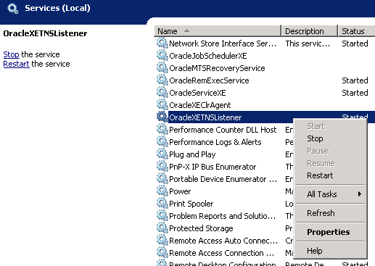

1. Choose the service from the list and right click to view the menu options for stopping, starting and restarting the service. OracleXETNSListener is the service that handles connections to database. OracleServiceXE is the service for the database engine.

# Backing up Server Log Files

All log files on both the Web Server and Database server should be backed up at regular intervals.

The following are the steps needed to back up the log files.

1. Login to the server and open the Windows ‘Event Viewer’ and expand the Windows logs folder.

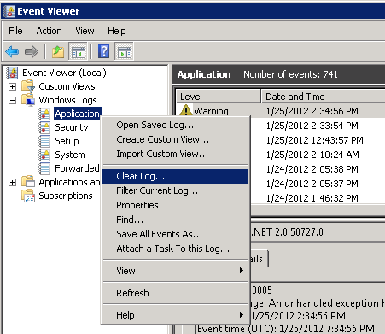

1. Right click the log file and choose the ‘Clear Log’ option, then click the ‘Save and Clear’ button to save the log files to a backup directory. Repeat the steps for all log files.

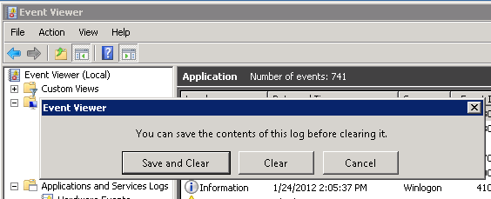

# Backing up Web Server IIS Log Files

1. Login to the Web Server and open IIS Manager and select the ‘Logging’ option.

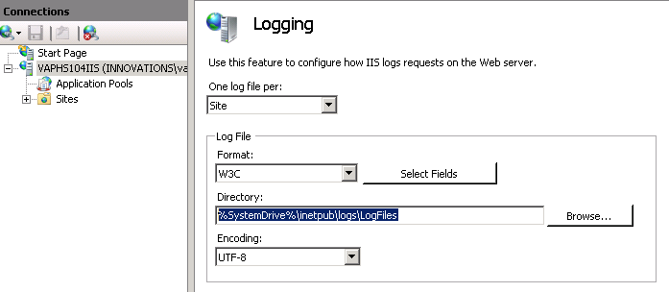

1. Navigate to the directory listed above and move the files to a backup directory.

